Instructions to Install MySQL

Go to http://dev.mysql.com/downloads/installer/   
You will see the screen below.

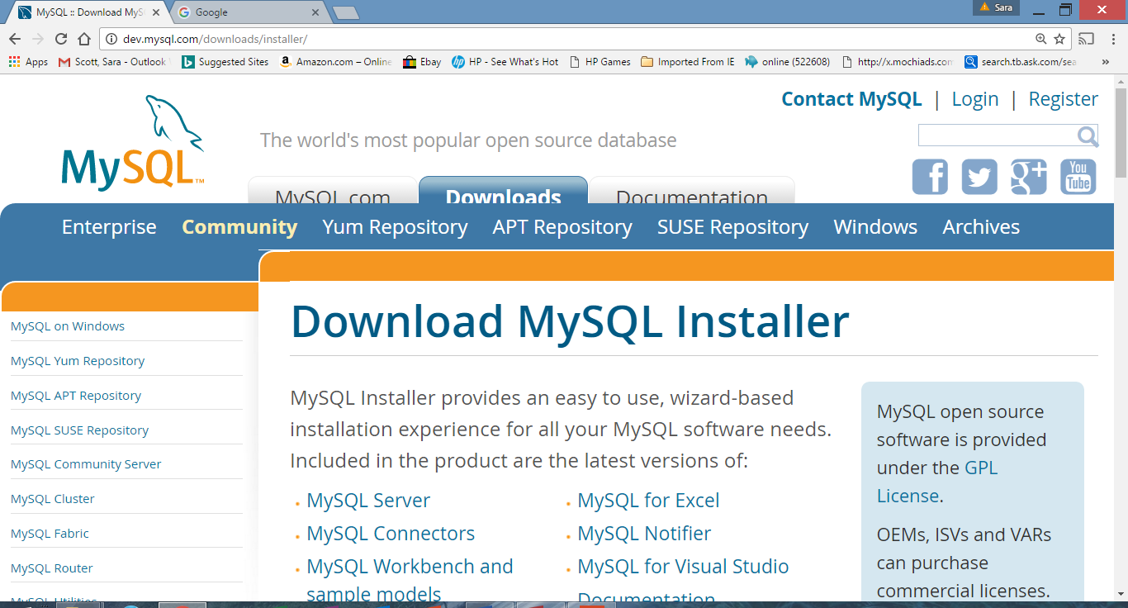

**Click on My SQL Community Server. Scroll down until the screen below appears.**

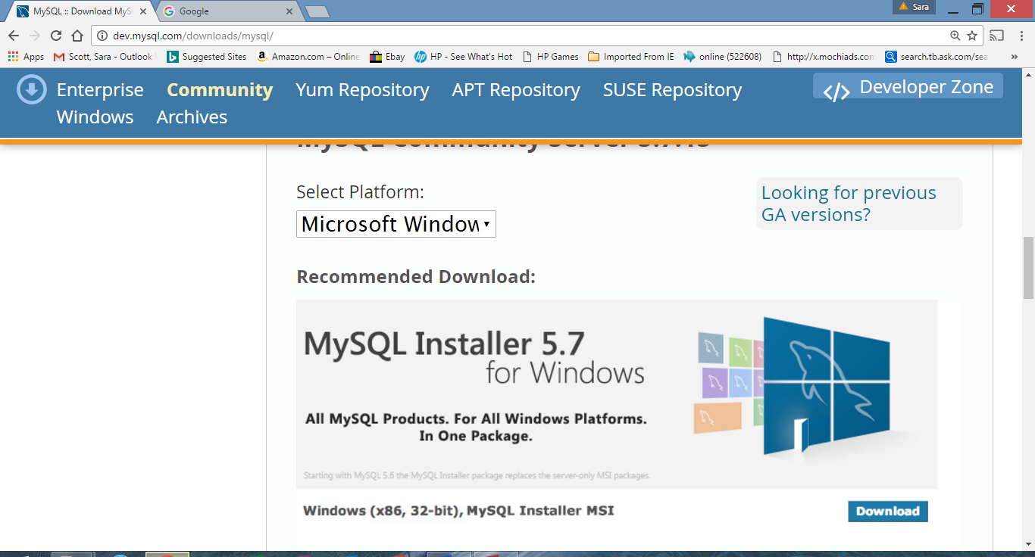

**Click Download. Scroll down until the screen below appears.**

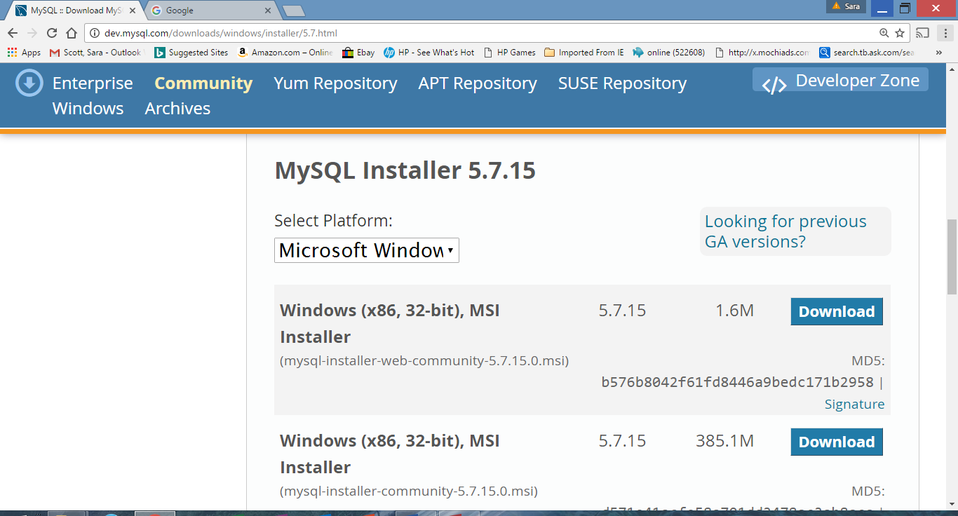

**You can use either of these, I will use the smaller version. Click Download. Scroll down until the screen below appears.**

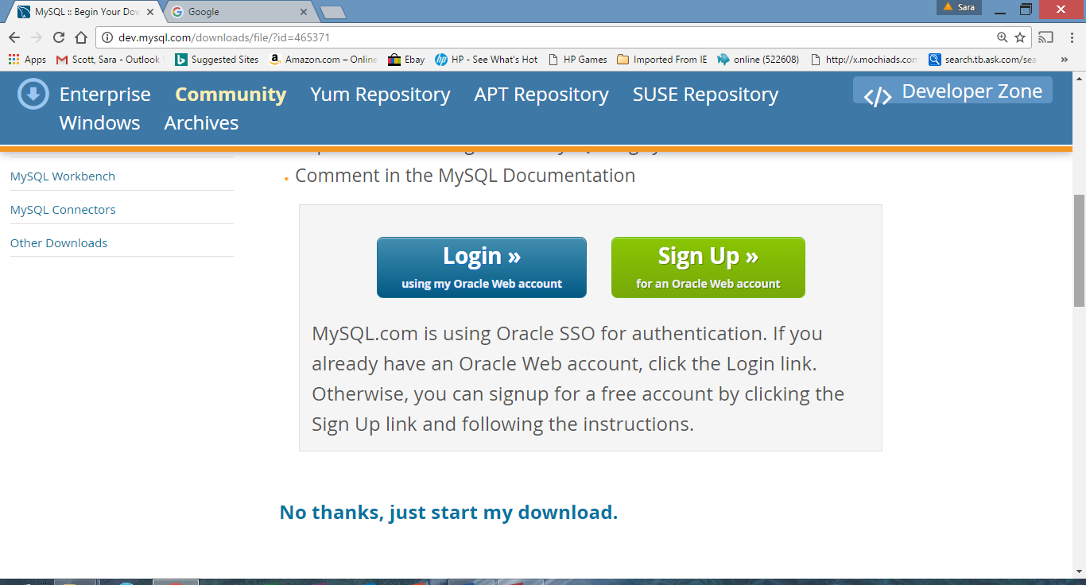

**Click No Thanks. The screen below appears.**

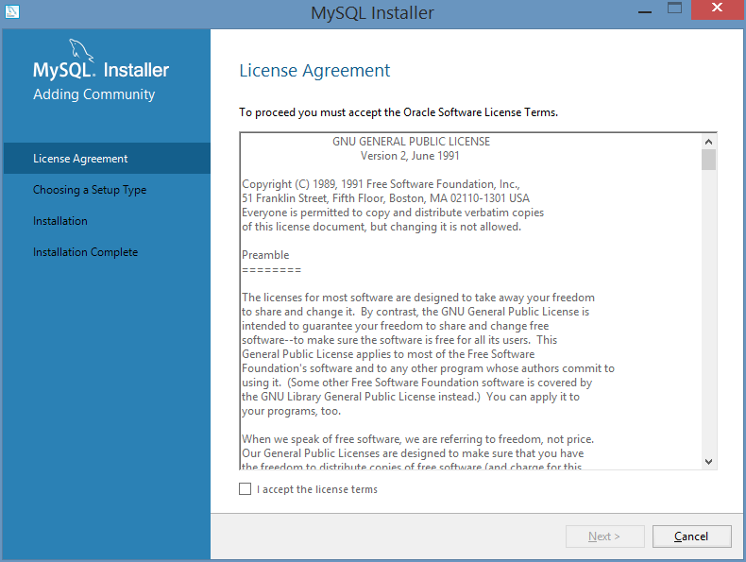

**Click I accept. You will have the option of saving the installer or running it at his point. To run now, open the installer file which is at the bottom left corner of the screen. This will begin the installer.**

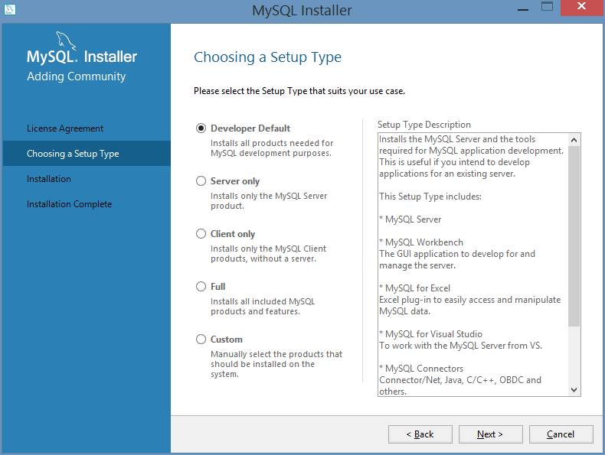

**Click Custom then click next. The screen below appears.**

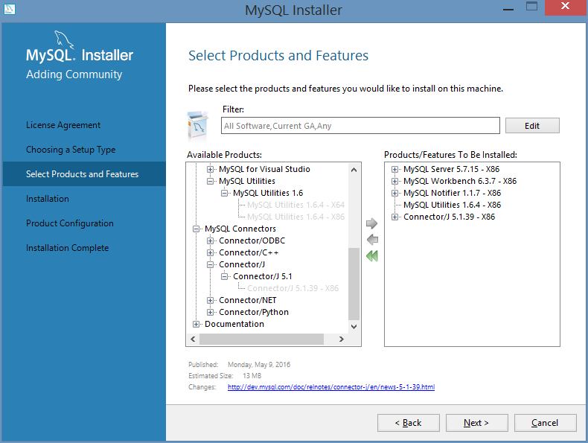

**Choose the products that you want. Be sure to get the workbench, then click next.  
The screen below appears.**

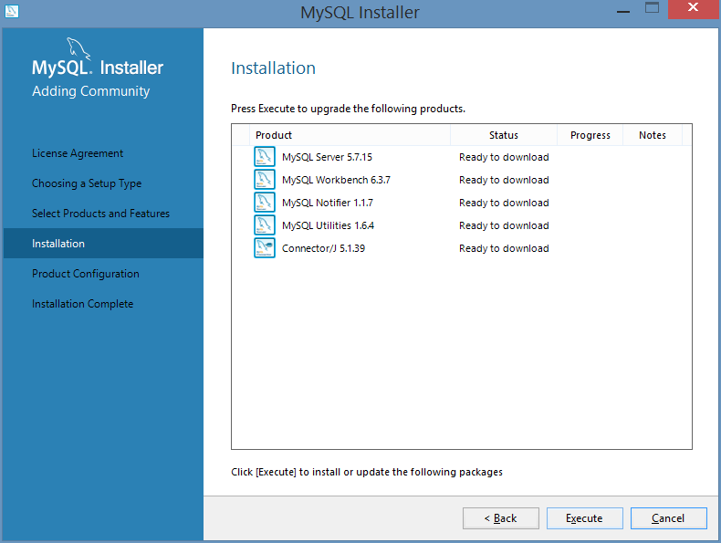

**Click execute. This may take a few minutes The screen below appears.**

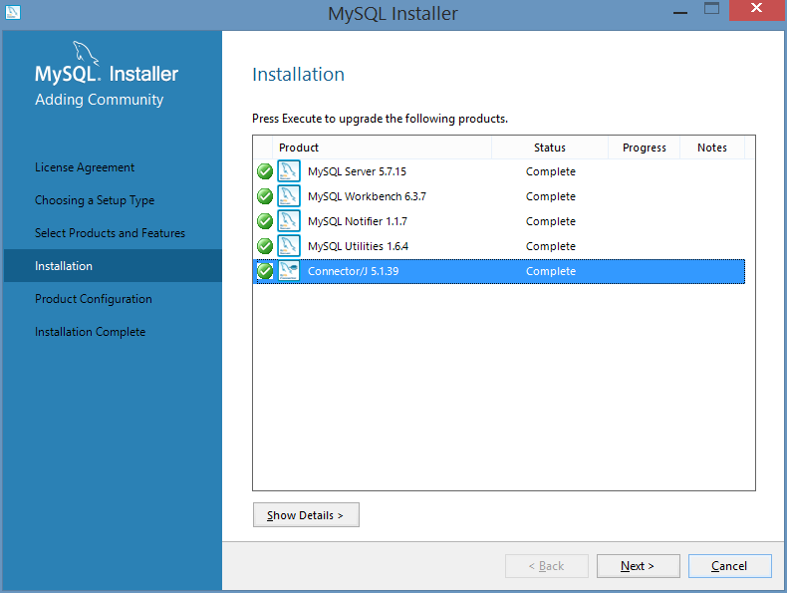

**Click next. This may take a few minutes The screen below appears.**

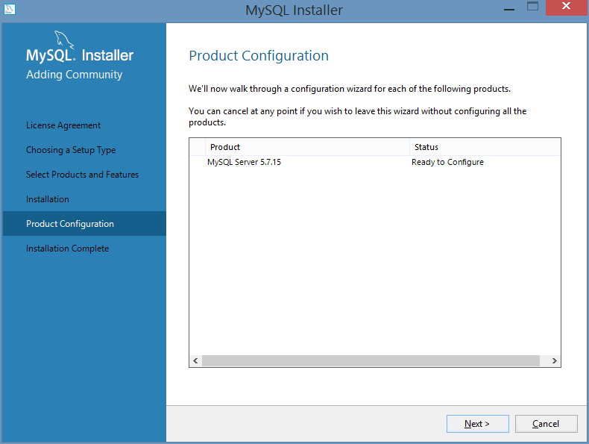

**Click next. This may take a few minutes Continue to click next until the screen below appears.**

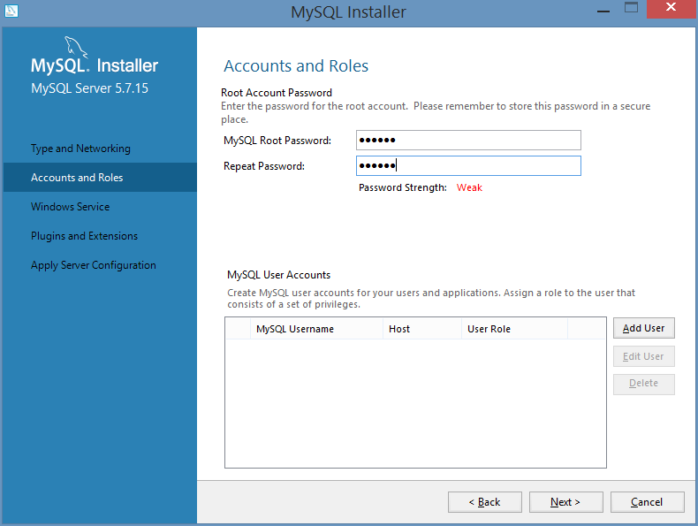

**Enter a password that you can remember. Click next. This may take a few minutes Continue to click next until the screen below appears.**

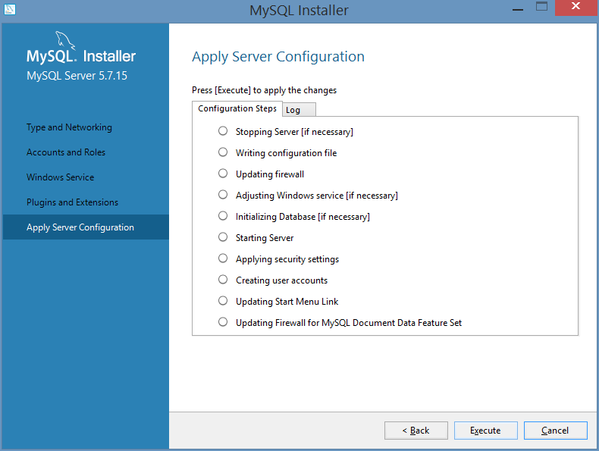

**Click execute. This may take a few minutes. The screen below appears.**

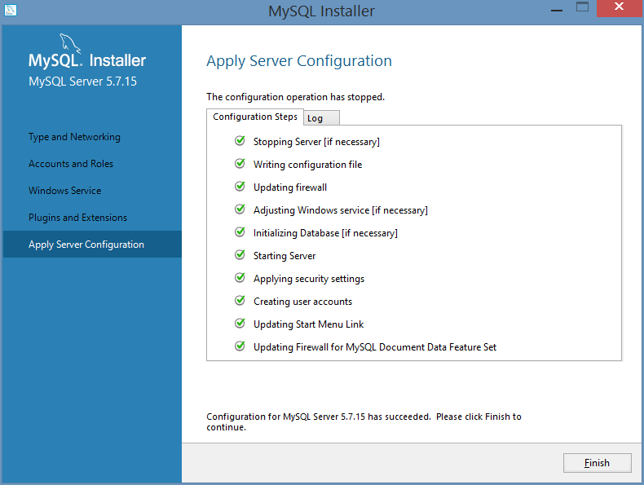

**Click finish. The installation should be finished.**